Countries with declining emissions

William F. Lamb

11 August, 2020

Table of Contents

Overview 4

Belgium 5

Bulgaria 6

Croatia 7

Cyprus 8

Czech Republic 9

Denmark 10

Equatorial Guinea 11

France 12

Gabon 13

Germany 14

Greece 15

Hungary 16

Ireland 17

Italy 18

Jamaica 19

Korea, Dem. People’s Rep. 20

Libya 20

Macedonia, FYR 22

Netherlands 23

New Zealand 24

Portugal 25

Romania 26

Slovak Republic 27

Slovenia 28

Spain 29

Swaziland 30

Sweden 31

Switzerland 32

Syrian Arab Republic 33

Timor-Leste 34

Ukraine 35

United Kingdom 36

United States 37

Venezuela, RB 38

Yemen, Rep. 39

### Overview

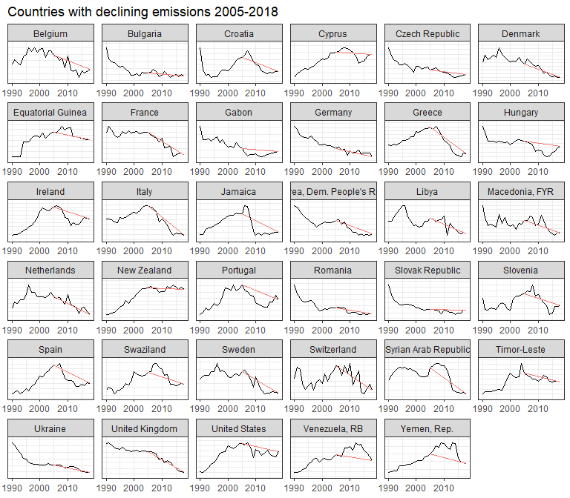

### Belgium

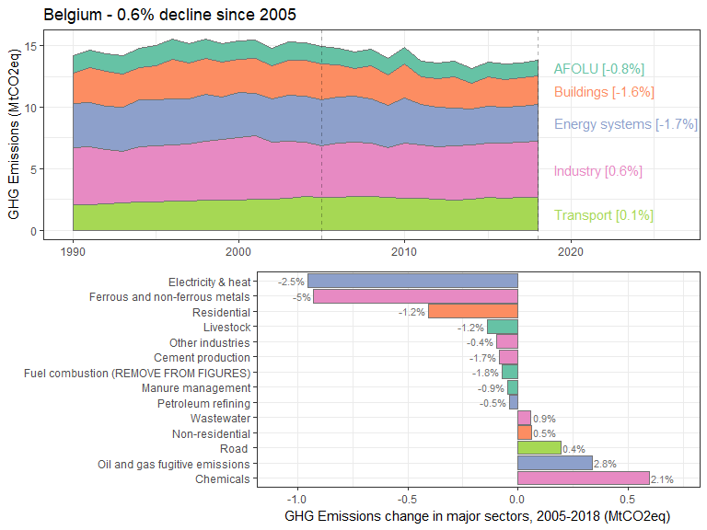

### Bulgaria

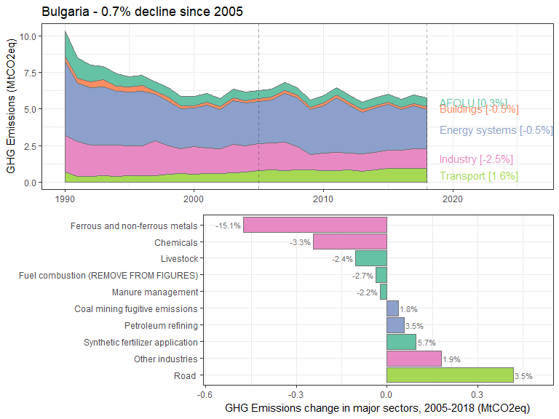

### Croatia

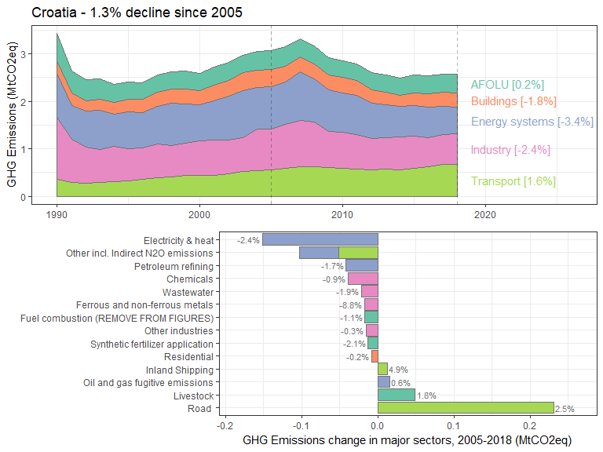

### Cyprus

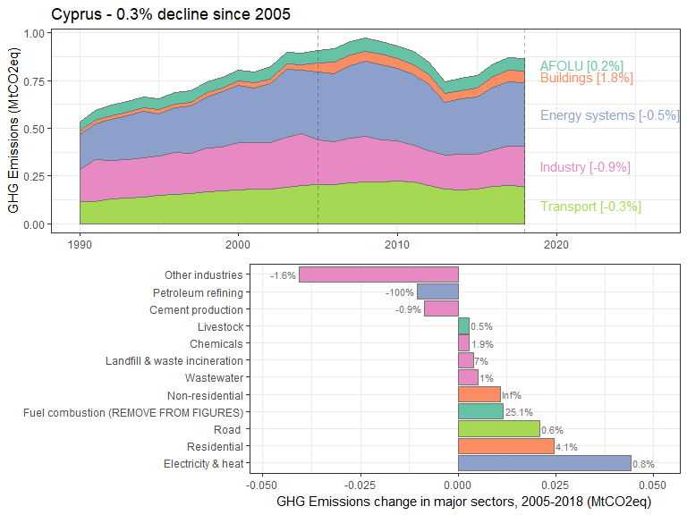

### Czech Republic

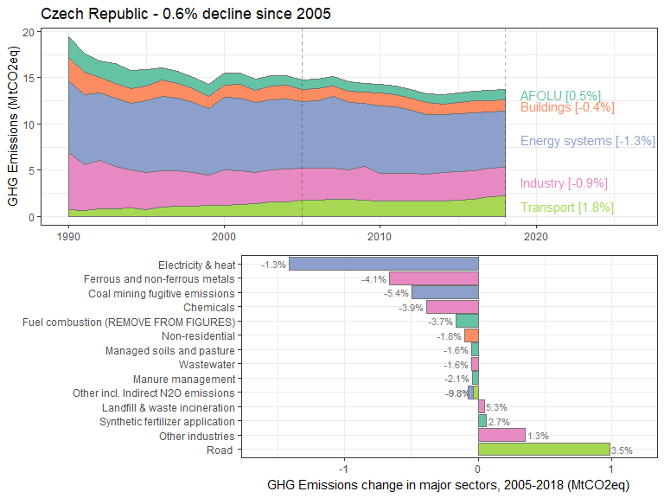

### Denmark

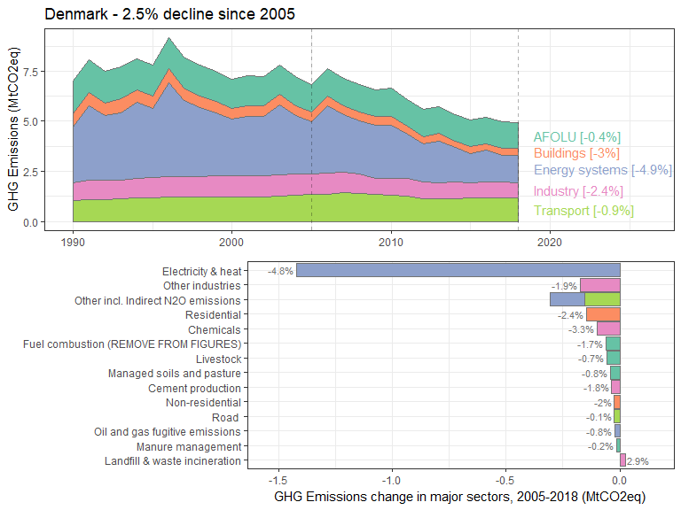

### Equatorial Guinea

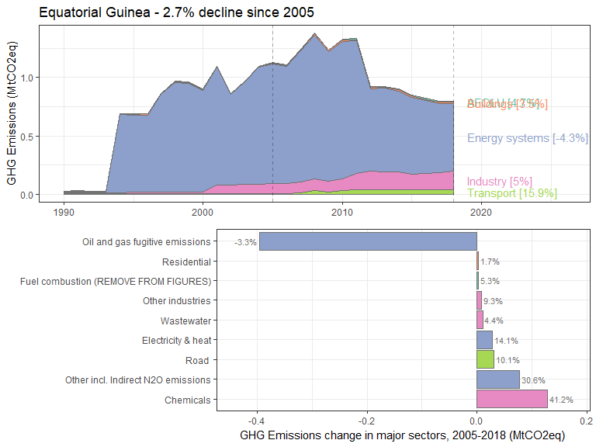

### France

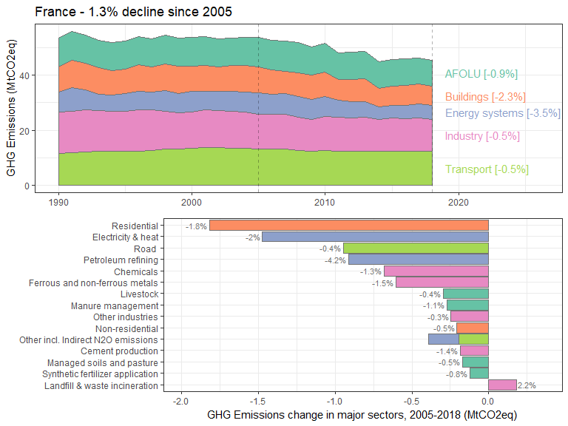

### Gabon

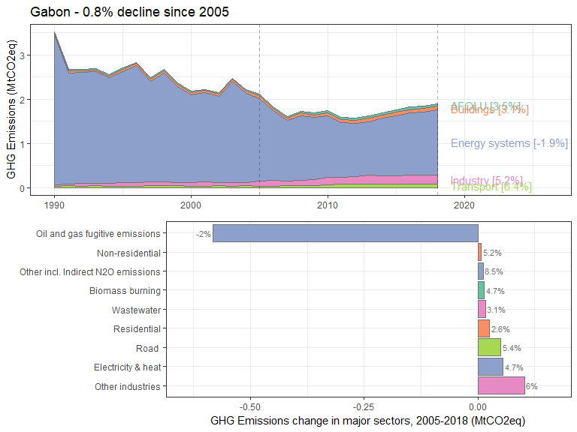

### Germany

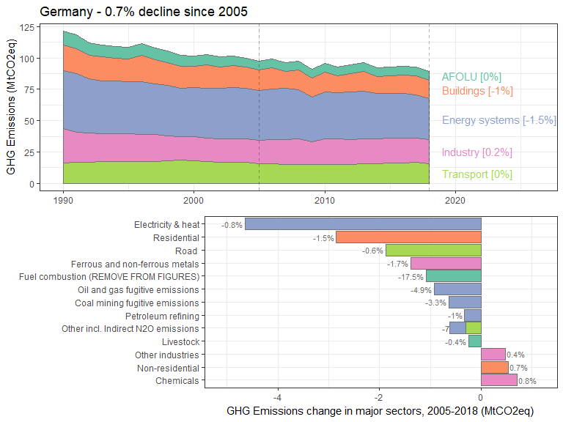

### Greece

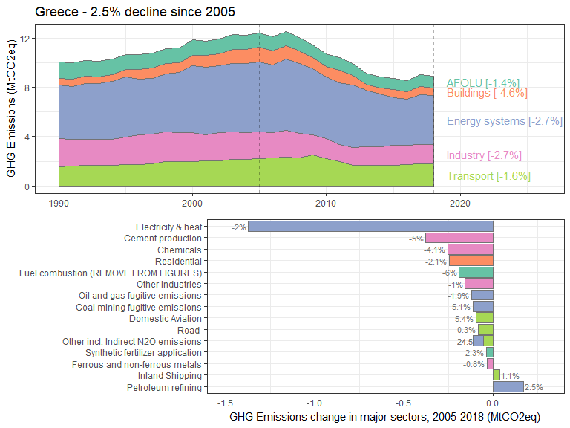

### Hungary

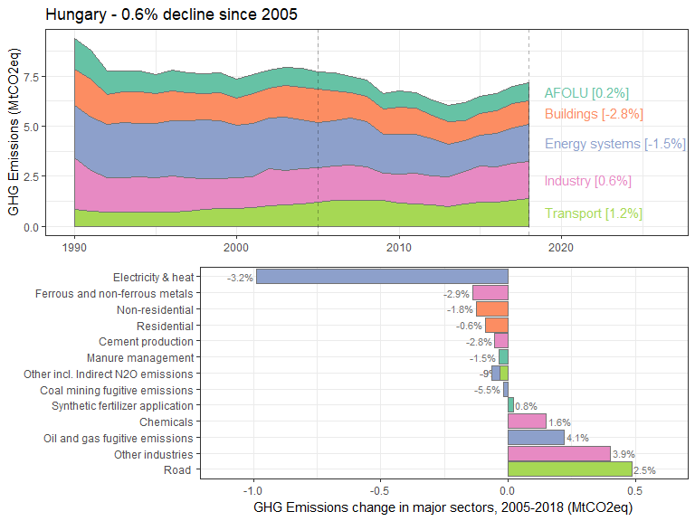

### Ireland

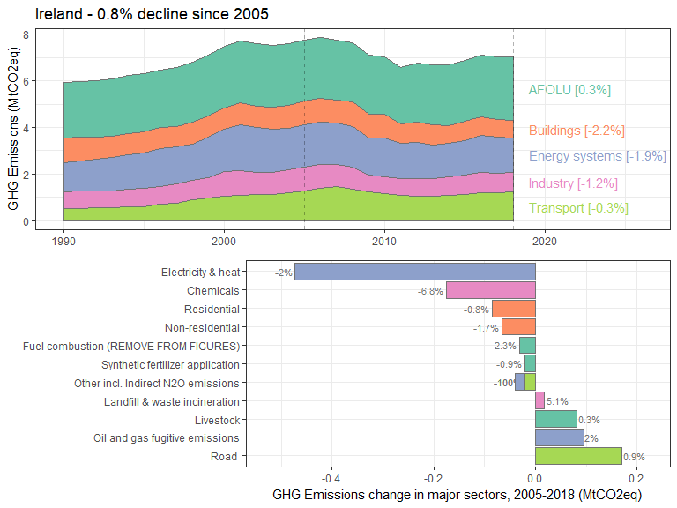

### Italy

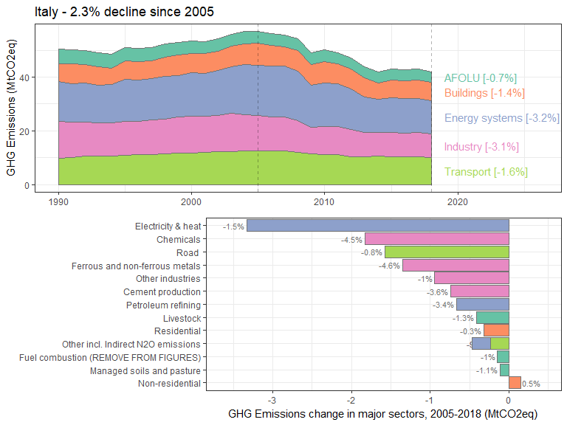

### Jamaica

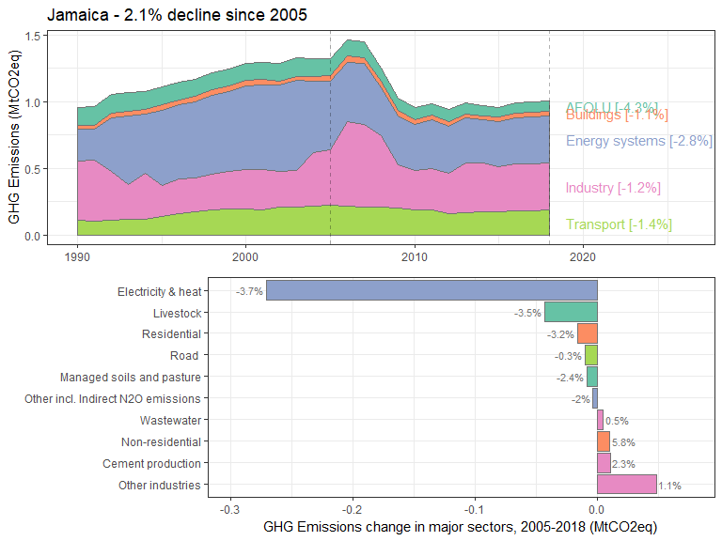

### Korea, Dem. People’s Rep.

### Libya

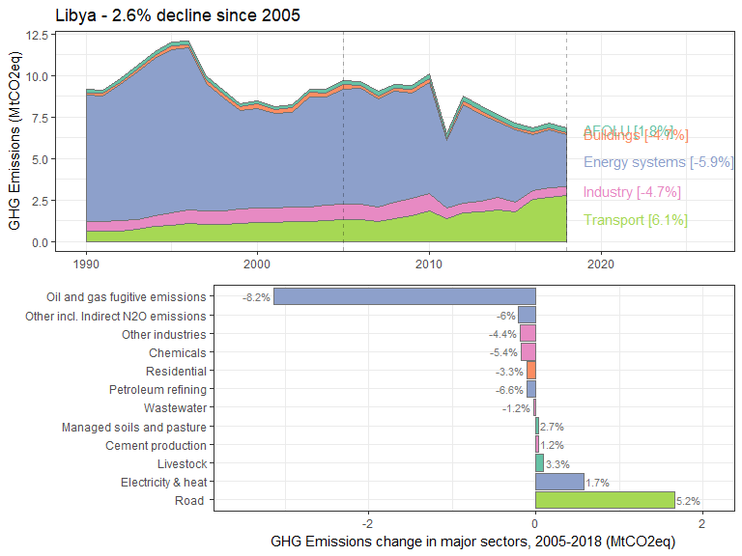

### Macedonia, FYR

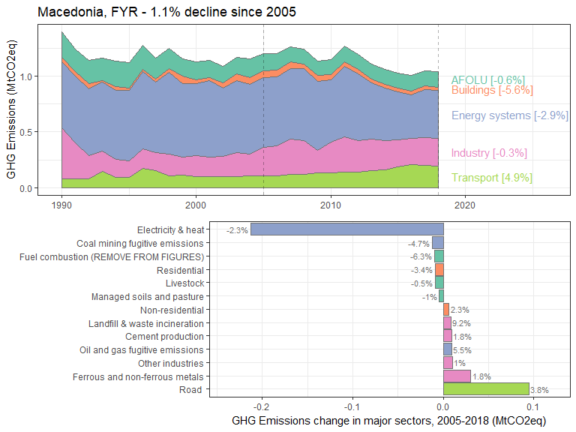

### Netherlands

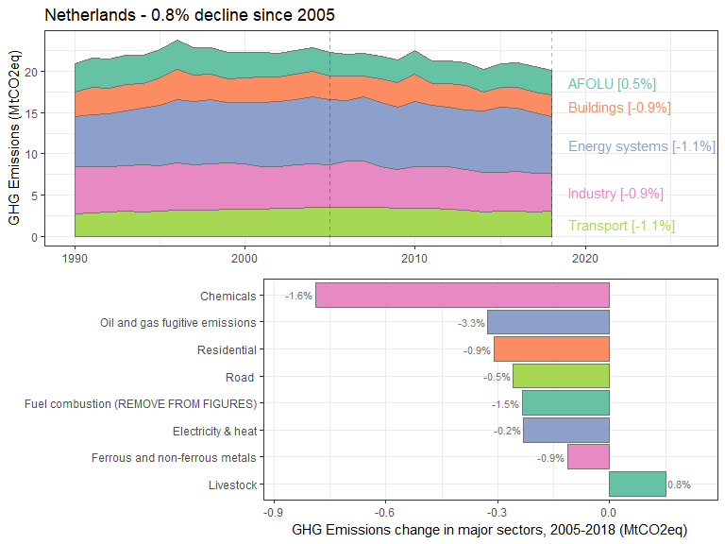

### New Zealand

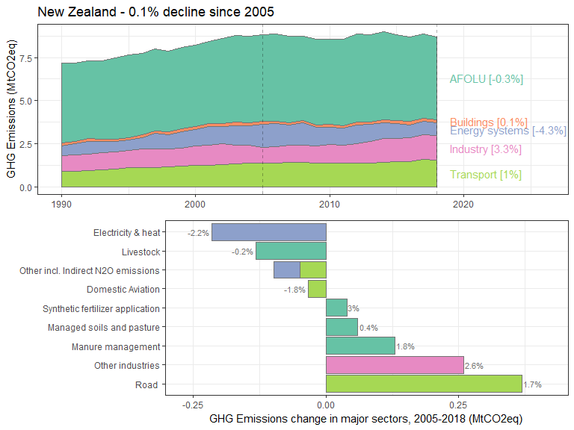

### Portugal

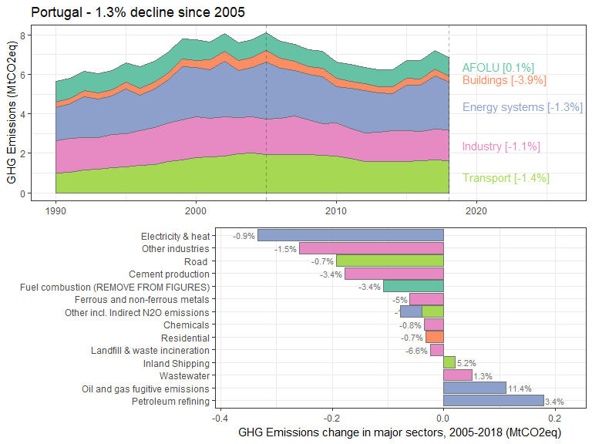

### Romania

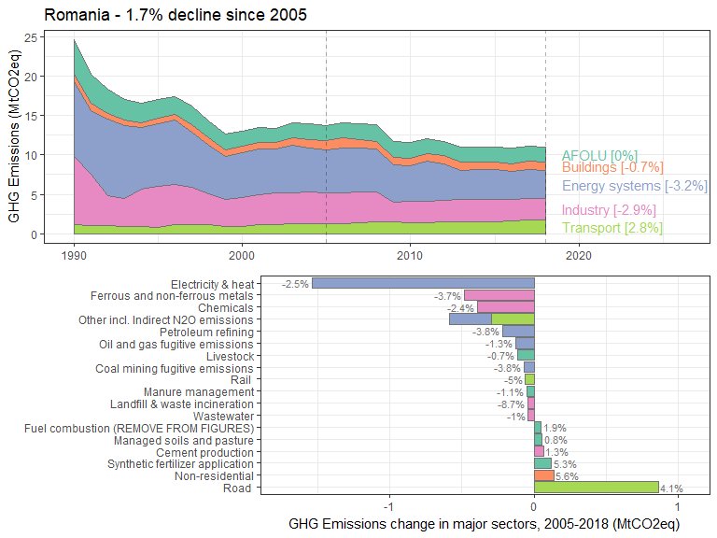

### Slovak Republic

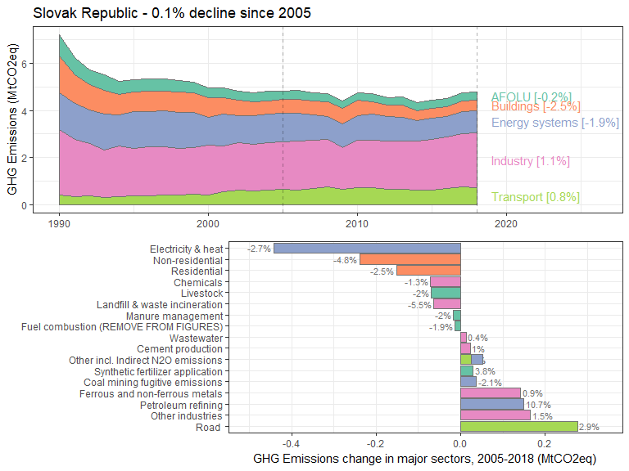

### Slovenia

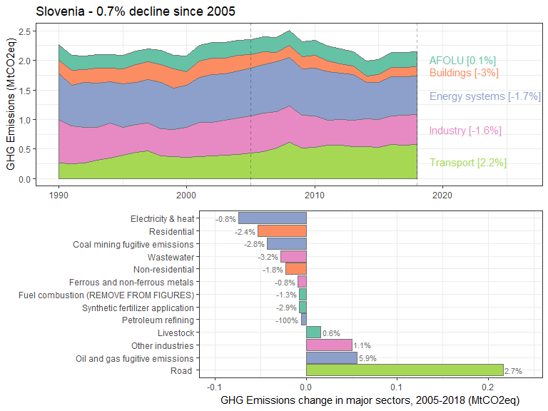

### Spain

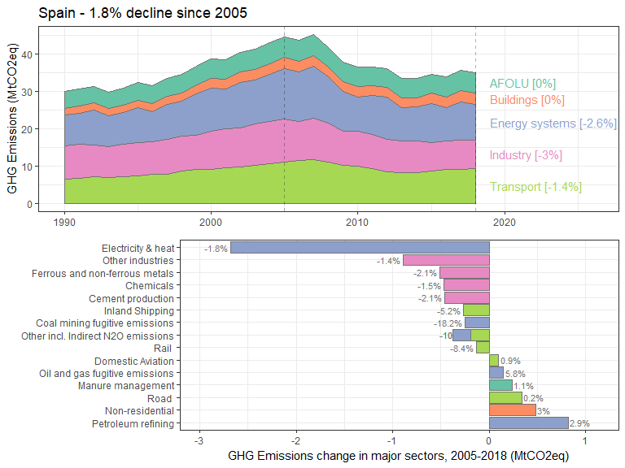

### Swaziland

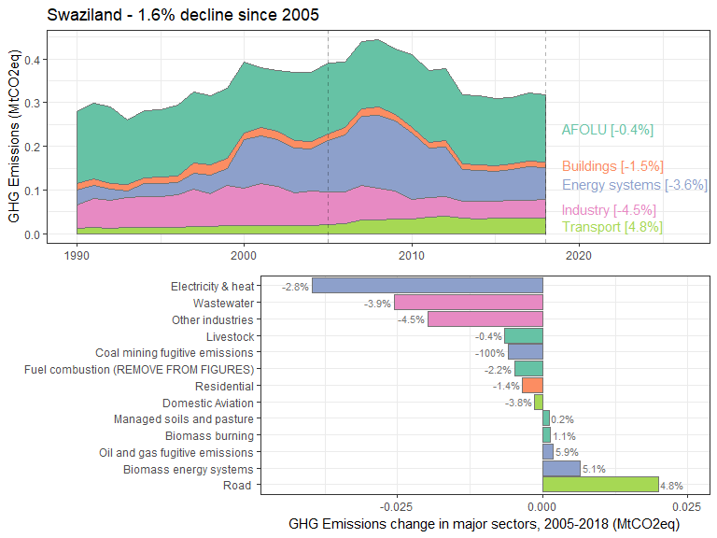

### Sweden

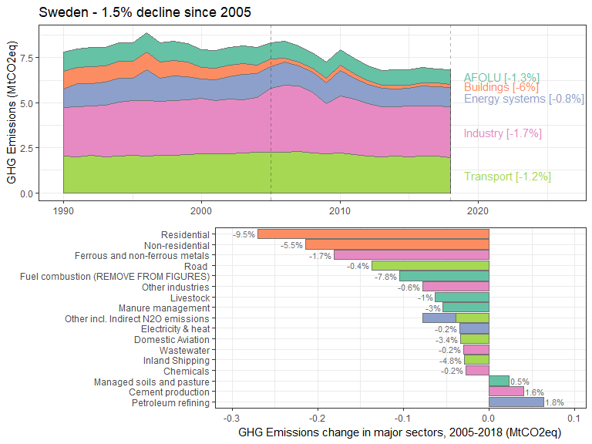

### Switzerland

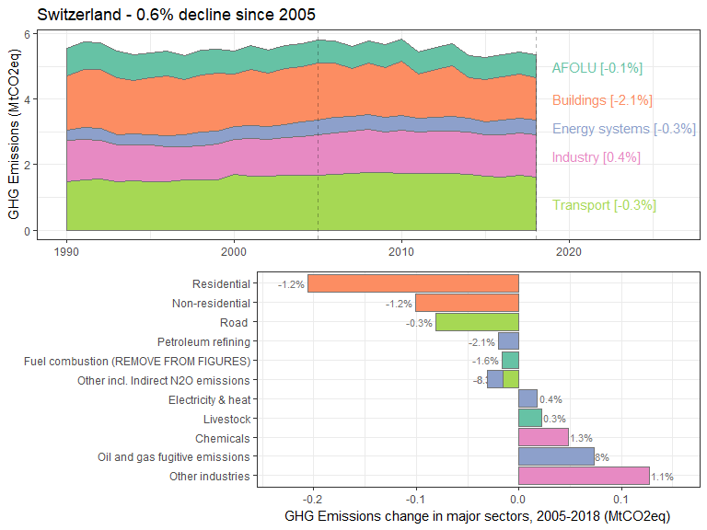

### Syrian Arab Republic

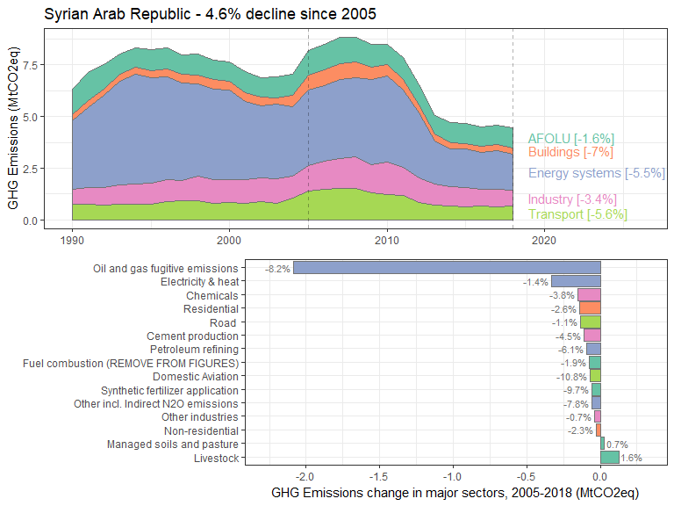

### Timor-Leste

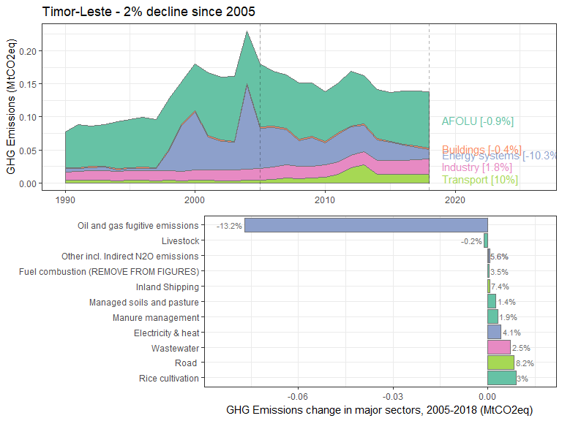

### Ukraine

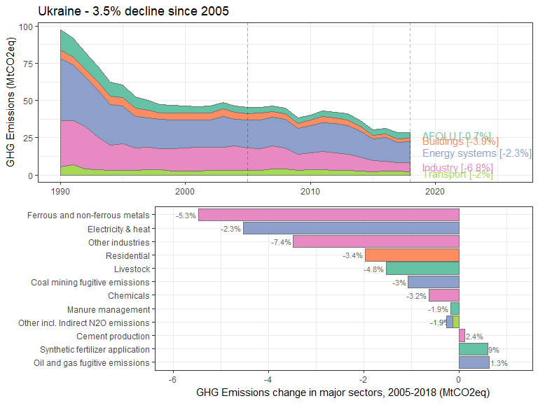

### United Kingdom

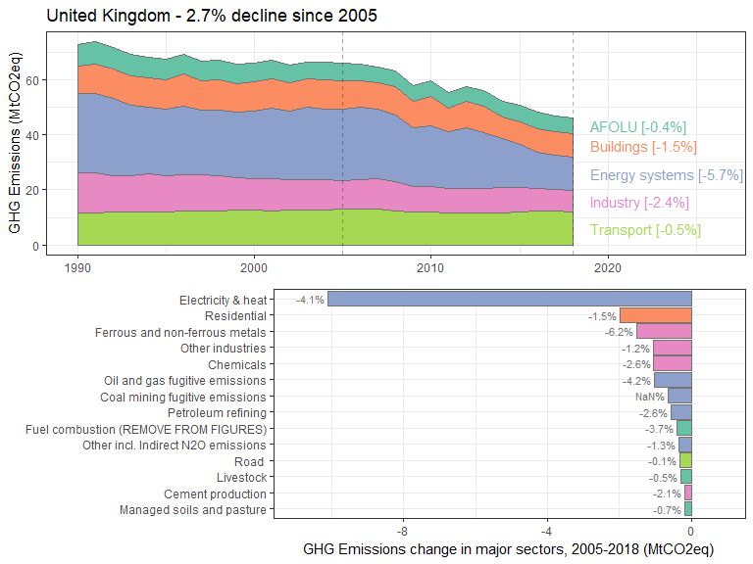

### United States

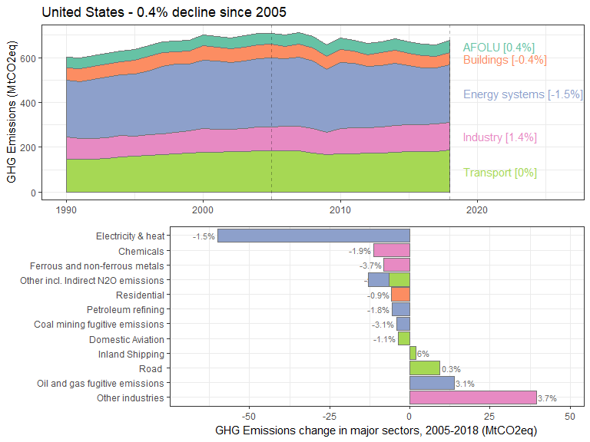

### Venezuela, RB

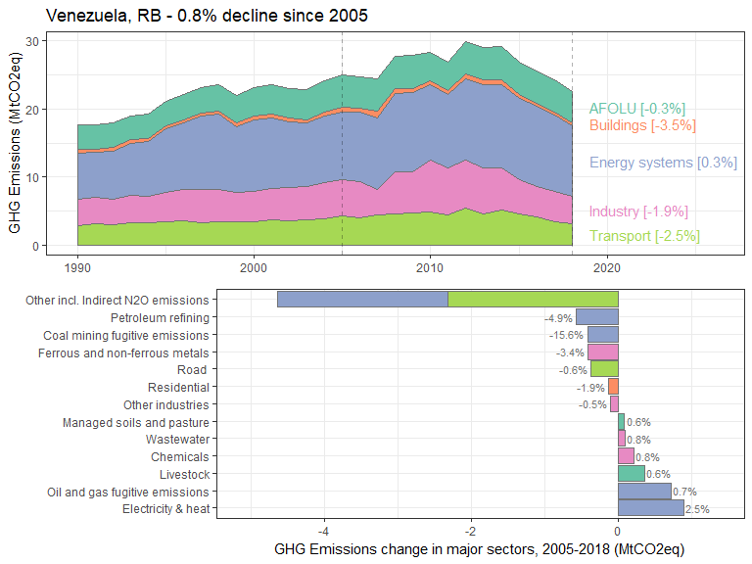

### Yemen, Rep.